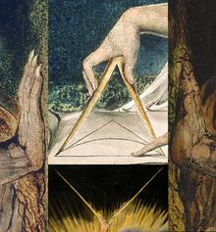 | Cover  1033.jpg  details
 | Liber Primus
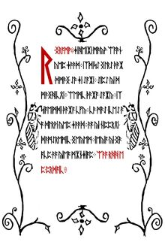 | A WARNING  BELIEVE NOTHING FROM THIS BOOK EXCEPT WHAT YOU KNOW TO BE TRUE  TEST THE KNOWLEDGE  FIND YOUR TRUTH  EXPERIENCE YOUR DEATH  DO NOT EDIT OR CHANGE THIS BOOK OR THE MESSAGE CONTAINED WITHIN EITHER THE WORDS OR THEIR NUMBERS  FOR ALL IS SACRED
 | Chapter 1  Intus
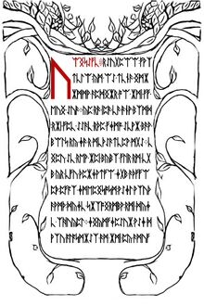 | WELCOME  WELCOME, PILGRIM, TO THE GREAT JOURNEY TOWARD THE END OF ALL THINGS  IT IS NOT AN EASY TRIP, BUT FOR THOSE WHO FIND THEIR WAY HERE IT IS A NECESSARY ONE  ALONG THE WAY YOU WILL FIND AN END TO ALL STRUGGLE AND SUFFERING, YOUR INNOCENCE, YOUR ILLUSIONS, YOUR CERTAINTY, AND YOUR REALITY  ULTIMATELY, YOU WILL DISCOVER AN END TO SELF
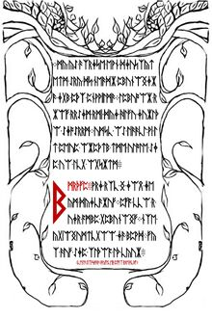 | IT IS THROUGH THIS PILGRIMAGE THAT WE SHAPE OURSELVES AND OUR REALITIES  JOURNEY DEEP WITHIN AND YOU WILL ARRIVE OUTSIDE  LIKE THE INSTAR, IT IS ONLY THROUGH GOING WITHIN THAT WE MAY EMERGE  WISDOM  YOU ARE A BEING UNTO YOURSELF  YOU ARE A LAW UNTO YOURSELF  EACH INTELLIGENCE IS HOLY FOR ALL THAT LIVES IS HOLY  AN INSTRUCTION COMMAND YOUR OWN SELF
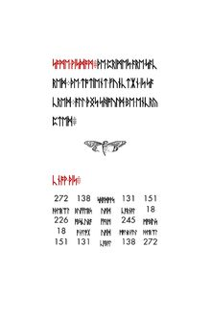 | SOME WISDOM  THE PRIMES ARE SACRED  THE TOTIENT FUNCTION IS SACRED  ALL THINGS SHOULD BE ENCRYPTED  KNOW THIS  272 138 shadows 131 151  aethereal buffers void carnal 18  226 obscura form 245 mobius  18 analog void mournful aethereal  151 131 cabal 138 272  272 138 341 131 151  366 199 130 320 18  226 245 91 245 226  18 320 130 199 366  151 131 341 138 272
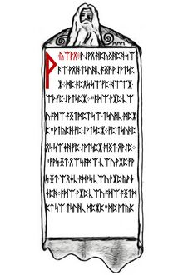 | A KOAN  A MAN DECIDED TO GO AND STUDY WITH A MASTER  HE WENT TO THE DOOR OF THE MASTER  "WHO ARE YOU WHO WISHES TO STUDY HERE" ASKED THE MASTER  THE STUDENT TOLD THE MASTER HIS NAME  "THAT IS NOT WHO YOU ARE, THAT IS ONLY WHAT YOU ARE CALLED  WHO ARE YOU WHO WISHES TO STUDY HERE" HE ASKE
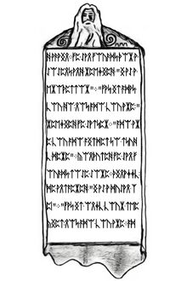 | D AGAIN  THE MAN THOUGHT FOR A MOMENT, AND REPLIED "I AM A PROFESSOR"  "THAT IS WHAT YOU DO, NOT WHO YOU ARE," REPLIED THE MASTER  "WHO ARE YOU WHO WISHES TO STUDY HERE"  CONFUSED, THE MAN THOUGHT SOME MORE  FINALLY, HE ANSWERED, "I AM A HUMAN BEING"  "THAT IS ONLY YOUR SPECIES, NOT WHO YOU ARE WH
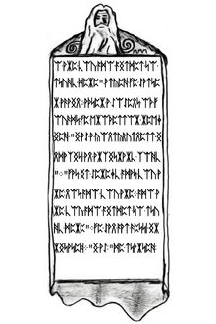 | O ARE YOU WHO WISHES TO STUDY HERE", ASKED THE MASTER AGAIN  AFTER A MOMENT OF THOUGHT, THE PROFESSOR REPLIED "I AM A CONSCIOUSNESS INHABITING AN ARBITRARY BODY"  "THAT IS MERELY WHAT YOU ARE, NOT WHO YOU ARE  WHO ARE YOU WHO WISHES TO STUDY HERE"  THE MAN WAS GETTING IRRITATED  "I AM," HE STARTED,
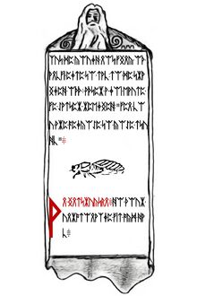 | BUT HE COULD NOT THINK OF ANYTHING ELSE TO SAY, SO HE TRAILED OFF  AFTER A LONG PAUSE THE MASTER REPLIED, "THEN YOU ARE WELCOME TO COME STUDY"  AN INSTRUCTION DO FOUR UNREASONABLE THINGS EACH DAY
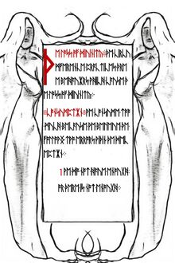 | THE LOSS OF DIVINITY  THE CIRCUMFERENCE PRACTICES THREE BEHAVIORS WHICH CAUSE THE LOSS OF DIVINITY  CONSUMPTION WE CONSUME TOO MUCH BECAUSE WE BELEIVE THE FOLLWING TWO ERRORS WITHIN THE DECEPTION  1. WE DO NOT HAVE ENOUGH, OR THERE IS NOT ENOUGH
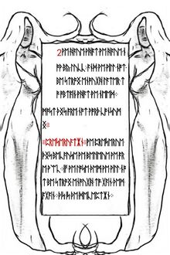 | 2. WE HAVE WHAT WE HAVE NOW BY LUCK; AND WE WILL NOT BE STRONG ENOUGH LATER TO OBTAIN WHAT WE NEED  MOST THINGS ARE NOT WORTH CONSUMING  PRESERVATION WE PRESERVE THINGS BECAUSE WE BELIEVE WE ARE WEAK  IF WE LOSE THEM WE WILL NOT BE STRONG ENOUGH TO GAIN THEM AGAIN  THIS IS THE DECEPTION
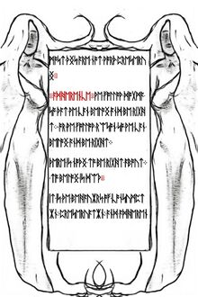 | MOST THINGS ARE NOT WORTH PRESERVING  ADHERENCE WE FOLLOW DOGMA SO THAT WE CAN BELONG AND BE RIGHT; OR WE FOLLOW REASON SO WE CAN BELONG AND BE RIGHT  THERE IS NOTHING TO BE RIGHT ABOUT; TO BELONG IS DEATH  IT IS THE BEHAVIORS OF CONSUMPTION, PRESERVATION, AND ADHEREN
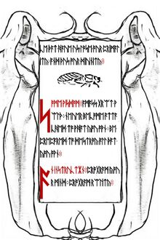 | CE THAT HAVE US LOSE OUR PRIMALITY, AND THUS OUR DIVINITY  SOME WISDOM  AMASS GREAT WEALTH  NEVER BECOME ATTACHED TO WHAT YOU OWN  BE PREPARED TO DESTROY ALL THAT YOU OWN  AN INSTRUCTION  PROGRAM YOUR MIND  PROGRAM REALITY
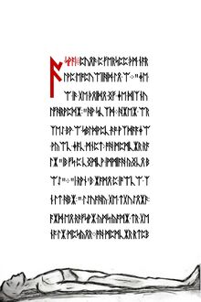 | 107.jpg  A KOAN  DURING A LESSON, THE MASTER EXPLAINED THE I  "THE I IS THE VOICE OF THE CIRCUMFERENCE," HE SAID  WHEN ASKED BY A STUDENT TO EXPLAIN WHAT THAT MEANT; THE MASTER SAID "IT IS A VOICE INSIDE YOUR HEAD"  "I DON'T HAVE A VOICE IN MY HEAD," THOUGHT THE STUDENT, AND HE RAISED HIS HAND TO TELL THE MASTER  THE MASTER STOP
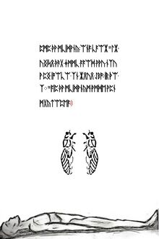 | 167.jpg  PED THE STUDENT, AND SAID "THE VOICE THAT JUST SAID YOU HAVE NO VOICE IN YOUR HEAD; IS THE I"  AND THE STUDENTS WERE ENLIGHTENED
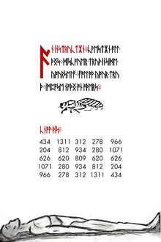 | 229.jpg  AN INSTRUCTION  KWESTION ALL THINGS  DISCOVER TRUTH INSIDE YOURSELF  FOLLOW YOUR TRUTH  IMPOSE NOTHING ON OTHERS  KNOW THIS  434 1311 312 278 966  204 812 934 280 1071  626 620 809 620 626  1071 280 934 812 204  966 278 312 1311 434
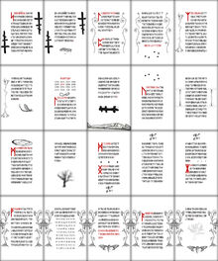 | 56 unsolved pages  0.jpg - 55.jpg  Liber Primus Unsolved Pages
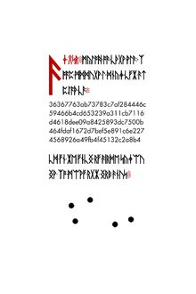 | 56.jpg  AN END  WITHIN THE DEEP WEB, THERE EXISTS A PAGE THAT HASHES TO  36367763ab73783c7af284446c  59466b4cd653239a311cb7116  d4618dee09a8425893dc7500b  464fdaf1672d7bef5e891c6e227  4568926a49fb4f45132c2a8b4  IT IS THE DUTY OF EVERY PILGRIM TO SEEK OUT THIS PAGE
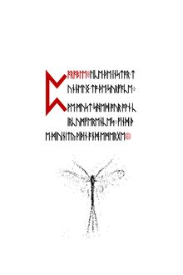 | 57.jpg  Parable :  Like the instar tunneling to the surface.  We must shed our own circumferences.  Find the divinity within and emerge.

